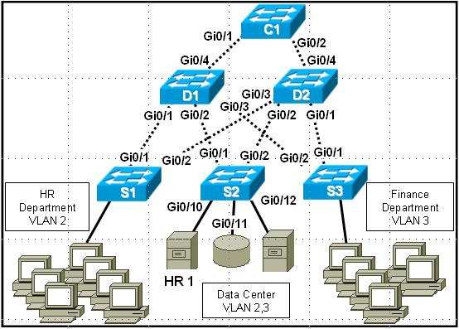
Refer to the exhibit. All switches except S3 are located in the MDF. The user community in HR has been reporting slow performance in all network applications since the HR1 application server was added to the data center. An extensive traffic analysis has shown that the Gi0/1 interface on S1 is frequently running at 100% bandwidth usage,
and Gi0/2 is blocked by Spanning Tree Protocol. Company policy requires that the HR department be segregated
from the general user community. There are no duplexing mismatches or cabling/hardware problems. All switches have available ports. What fix will alleviate the problem and meet company requirements?
Manually enable the Gi0/2 port on S1 to split the traffic load.
Divide the HR population between S1 and S3 to distribute the load between switches.
Add a second HR application server and cluster them to reduce the load.
Move the HR 1 Ethernet connection to S1 to reduce cross switch traffic.

2 To help select the optimal model of a replacement switch for a department, a network administrator performs extensive analysis of current and future usage. The administrator specifically examines how heavily the entire user community hits specific application servers, the additional load that expected future hires will place on the
servers, and how much storage space future users will need. This is an example of what kind of analysis?
data stores and data servers
user communities
network configuration management
convergence impact

3 What is an important characteristic of a distribution level switch?
PoE
port speed
QoS prioritization
aggregating distribution layer switches

4 Which characteristics are associated with a device operating at the distribution layer of a hierarchical network design?
high speed, highly available, and redundant
policy-based connectivity and departmental or workgroup access to the core layer
connectivity to end devices between work spaces and building floors
high end devices capable of handling large amounts of data

5 Which hierarchical design characteristic would be recommended at both the core and distribution layers to protect the network in the case of a route failure?
switching
redundancy
aggregation
access lists

6 Which layer of the hierarchical design model provides a means of connecting devices to the network and controlling which devices are allowed to communicate on the network?
application
access
distribution
network
core

7 Which hierarchical design model layer controls the flow of network traffic using policies and delineates broadcast domains by performing routing functions between virtual LANs (VLANs)?
application
access
distribution
network
core

8 Which feature supports higher throughput in switched networks by combining multiple switch ports?
network diameter
load balancing across trunks
convergence
link aggregation

9 Which two features are supported at all three levels of the Cisco three-layer hierarchical model? (Choose two.)
Power over Ethernet

load balancing across redundant trunk links
redundant components
Quality of Service

link aggregation

10 Which three statements describe the benefits of a hierarchical network model? (Choose three.)
Scalability -- the design allows expansion which is easy to implement.
Performance -- load balancing across trunk links.
Manageability -- the network design enables the administrator to add switches by sharing configuration
information between devices.
Portability -- intermediary devices can be moved to alternative locations in the network when necessary to accommodate new users.
Link aggregation -- creating a full mesh topology by adding hardware devices to improve bandwidth.
Security -- ability to control which devices are allowed connectivity to the network.

11 Which layer of the hierarchical network design model is refered to as the high-speed backbone of the internetwork, where high availability and redundancy are critical?
access
distribution
network
core
workgroup
WAN

12 At which heirarchical layer are switches normally not required to process all ports at wire speed?
core layer
distribution layer
access layer
entry layer

13 What two factors are important to consider when designing a switched network for a small business of one to twenty employees? (Choose two.)
Layer 3 functionality
cost

modular construction
high port density
PoE

14 Configuring communication between devices on different VLANs requires the use of which layer of the OSI
model?
Layer 1
Layer 3

Layer 4
Layer 5

15 What statement best describes a modular switch?
a slim-line chassis
allows interconnection of switches on redundant backplane
defined physical characteristics
flexible characteristics

82.9

What is the likely impact of moving a conventional company architecture to a completely converged network?
QoS issues are greatly reduced.

Which two characteristics are associated with enterprise level switches? (Choose two.)
high forwarding rate
support link aggregation

94.3%

